**Supplementary**

**The line bisection bias as a deficit of proportional reasoning - Evidence from Number Line Estimation in Neglect**

S. Smaczny, E. Klein, S. Jung, K. Moeller, H.-O. Karnath

**In-depth elaboration of patients P3, P12, P19, and P20 in the segmentations task**

In the ‘quarters’ subtask, one N+ (P3) and two NLB+ (P12, P19) patients showed a response pattern indicating that they placed all three marks very close to one another instead of truly disecting the line into equal segments. Also, the same patient from the N+ group (P3) and a different patient from the NLB+ group (P20) behaved very differently from the rest of their groups in the ‘thirds’ subtask.

Figure S1 presents mean responses by P3 in the “quarters” subtask who attempted the task but showed highly untypical responses compared to the rest of their group. Group N+ generally was able to dissect the line into 4 equal segments, only P3 placed all three lines very close to one another, and all of them into the left half of the line (see also Figure 2 of the main manuscript). This suggests that P3 was not able to correctly carry out this task. For this reason, we excluded P3 for a second, additional analysis.

**Figure S1**: Comparison of P3 with the rest of group N+ in the “quarters” subtask

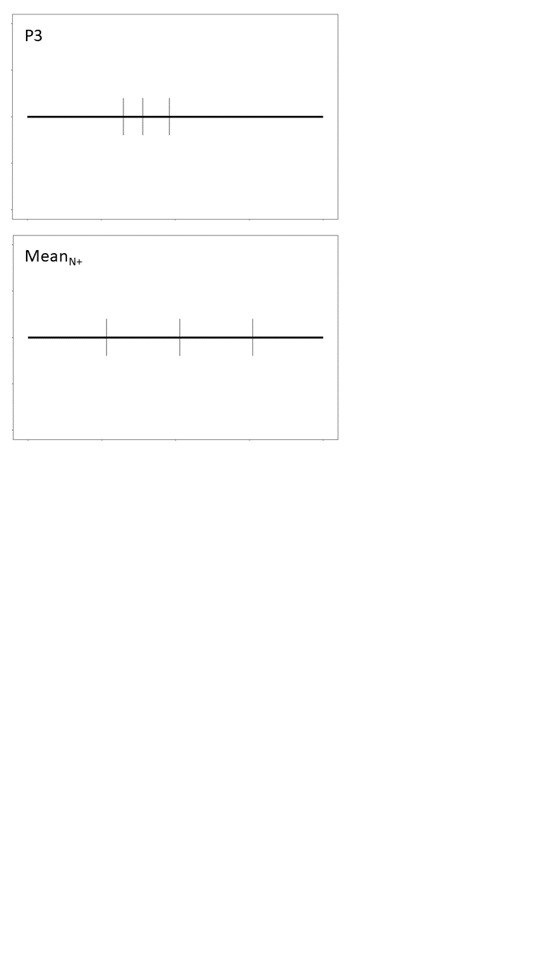

Such highly untypical response patterns could also be found for two members of group NLB+ in the “quarters” subtask (cf. Figure S2). While showing great variation, Group NLB+ generally showed behavior indicating an attempt to dissect the line into 4 equal segments, only that their responses were all skewed towards the right, as if they were unaware of the left end of the line. On the other hand, P12 and P19 just placed all lines very close to one another, suggesting that they were not able to carry out the task correctly. Therefore, we excluded them for a second, additional analysis of the “quarters” task.

**Figure S2**: Comparison of P12 and P19 with the rest of the NLB+ group

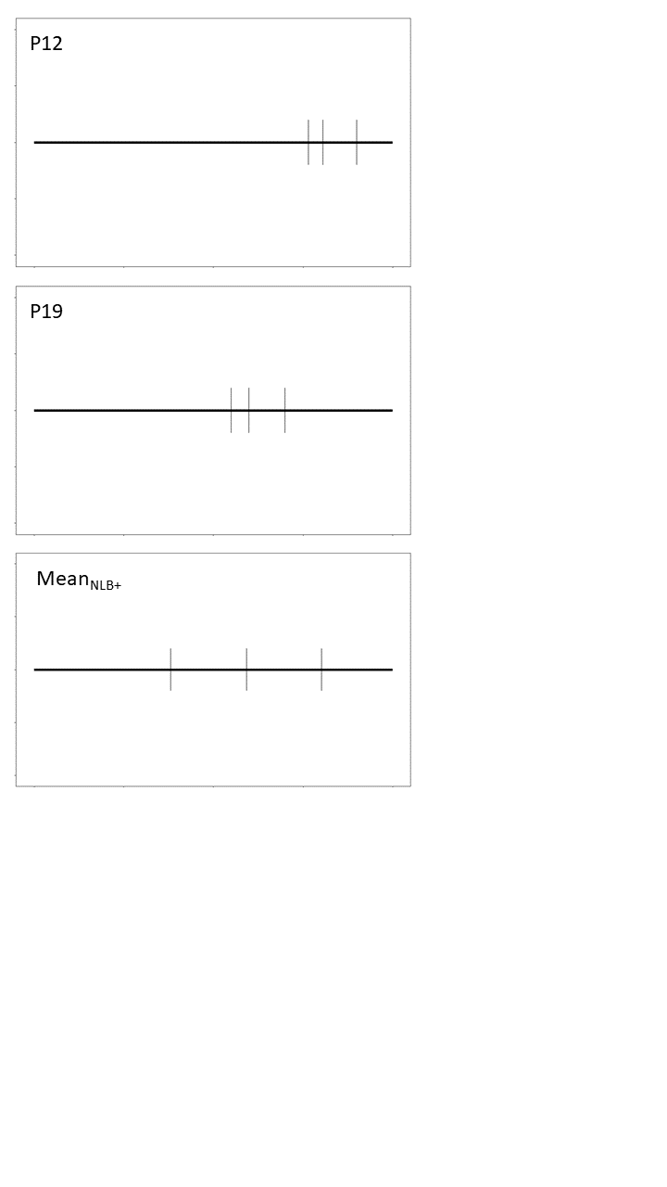

Similar issues arose for the “thirds” subtask. Again, P3 placed both marks very close to one another, while the rest of the N+ group showed no pronounced difficulties dissecting the line (Figure S3). Interestingly, P20 of the NLB+ group showed highly unusual behaviour in the “thirds” subtask, placing their left mark extremely to the left and their right mark extremely to the right (Figure S4). Therefore, P20 was also excluded from the analysis of the “thirds” task.

**Figure S3**: Comparison of P3 with the rest of group N+ in the “thirds” subtask

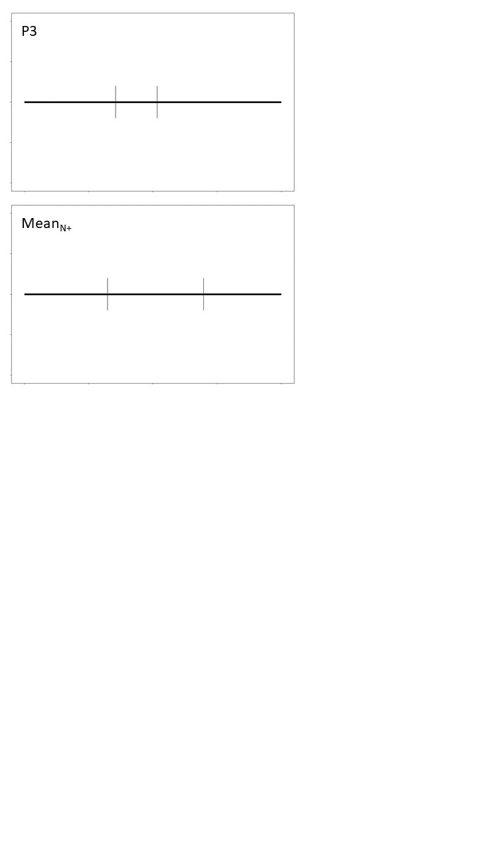

**Figure S4**: Comparison of P20 with the rest of group NLB+ in the “thirds” subtask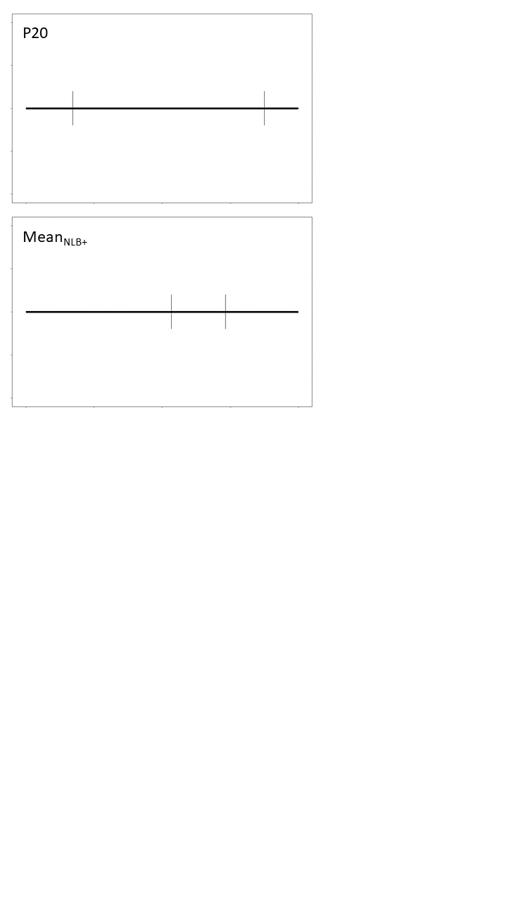

**Data analysis using a more liberal cut-off value of 6.5% for the diagnostic line bisection task**

When employing a more liberal cut-off value of 6.5% for the diagnostic line bisection task, all patients from the N+ group apart from one were included in the NLB+ group. Therefore, we had to exclude the N+ group from this analysis. Apart from this, the same exclusions were made as in our analysis using a cut-off of 14% (see main manuscript) whenever patients were not able to carry out a task. Descriptives for all tasks on the basis of the more liberal value of 6.5% for the diagnostic line bisection task are illustrated in Table S1.

**Table S1:** Descriptive for all groups and all tasks

|  |  |  |  |  |
| --- | --- | --- | --- | --- |
|  |  | HC | N- | NLB+ |
| LB |  | -0.17 (0.32) | 0.26 (0.69) | 2.24 (2.48) |
|  |  |  |  |  |
| Quarters segmentations | 1/4 | -0.08 (0.26) | -0.22 (0.57) | 2.86 (3.64) |
| 2/4 | -0.02 (0.27) | 0.01 (0.66) | 1.65 (2.08) |
| 3/4 | 0.10 (0.33) | 0.21 (0.59) | 0.73 (1.18) |
|  |  |  |  |  |
| Thirds segmentations | 1/3 | -0.25 (0.33) | -0.25 (0.48) | 1.55 (3.35) |
| 2/3 | 0.12 (0.36) | 0.28 (0.60) | 1.63 (1.76) |
|  |  |  |  |  |
| Fractions | 1/4 | -0.21 (0.82) | -0.02 (0.59) | 0.79 (3.23) |
|  | 1/3 | -0.05 (0.39) | 0.20 (2.52) | 0.66 (3.98) |
|  | 1/2 | -0.04 (0.35) | 0.11 (0.54) | 0.49 (1.22) |
|  | 2/4 | 1.08 (0.36) | 1.61 (1.07) | 0.96 (2.17) |
|  | 2/3 | -0.35 (0.81) | 0.70 (1.17) | -3.22 (4.01) |
|  | 3/4 | -1.18 (0.53) | -1.73 (1.60) | -1.93 (2.29) |
|  |  |  |  |  |
| Whole Numbers | 1 | .02 (0.61) | -0.52 (0.53) | -0.84 (1.50) |
| 4 | -0.22 (0.41) | 1.36 (3.85) | 0.26 (0.83) |
|  | 5 | -0.05 (0.31) | 1.06 (2.80) | 0.44 (1.34) |
|  | 6 | -0.26 (0.43) | 0.26 (2.50) | 0.17 (0.84) |
|  | 9 | -0.26 (0.40) | -0.12 (0.84) | 0.70 (0.60) |
| Verbal Number  Bisection | (mean) | -0.03 (0.10) | -0.35 (0.64) | -0.59 (0.74) |
|  |  |  |  |  |

Data provide mean deviations in cm relative to the true position of the respective mark and (SD) of all groups for all line tasks. Positive values denote a bias to the right.

Experimental Line Bisection

Figure S5 illustrates participants’ deviation from the centre of the line in the line bisection task. As expected, there was at least one significant difference between two of the four groups as indicated by the Kruskall-Wallis test [*H*(3) = 13.415, *p* = .001]. Post-hoc tests indicated a significant difference between HC and NLB+ (adj. *p* = .001), whereby patients with a line bisection bias showed a larger deviation from the centre as compared to healthy controls.

**Figure S5:** Mean line bisection bias for each group. The y-axis represents participants’ deviation in cm relative to the correct midpoint. Positive values denote a rightward bias.

Segmentation

In the *segmentation* task, the same lines as used before in *the experimental line bisection task* were presented. However, now the participants were required to dissect the line into either 4 (‘quarters task’) or 3 (‘thirds task’) equally sized segments.

Figure S6 illustrates the difference between participants’ marks and the correct positions of respective marks for the ‘quarters’ subtask; Figure S7 for the ‘thirds’ subtask. Table S2 presents the corresponding results of the accompanying Kruskal-Wallis tests, respectively. There was evidence for significant group differences in both subtasks: For the *quarters* task, the Kruskal-Wallis results indicated significant group differences for the two left lines (i.e., indicating the 1/4 and 1/2 segment of the line). Post-hoc tests revealed a significant difference between the NLB+ and HC group as well as the NLB+ and the N- group for the 1/4 mark, placing them further to the right than the other groups. Yet, these results did not remain significant when controlling for multiple testing.

Additionally, there was a significant difference between the NLB+ group and all other groups for the 1/2 line. Participants from the NLB+ group placed their marks significantly further to the right than all other groups for the 1/2 mark. Yet, like 1/4, they did not remain significant after controlling for multiple testing. In the right mark (2/3) of the ‘thirds’ task, groups also differed significantly. NLB+ placed the 2/3 mark significantly further to the right than group HC, even after controlling for multiple testing (adj. p < .05).

**Figure S6:** Quarters task. The x-axis reflects groups; the y-axis denotes the mean deviation from the correct position of the respective mark in cm. Black dots present mean responses of individual participants.

**Figure S7:** Thirds task. The x-axis reflects groups; the y-axis denotes the mean deviation from the correct position of the respective mark in cm. Black dots present mean responses of individual participants.

|  |  |  |  |
| --- | --- | --- | --- |
| **Table S2: Kruskal-Wallis test results for group differences for each line mark in the ‘quarters’ and ‘thirds’ subtasks.** | | | |
| **Subtask** | **Position** | ***H* (df)** | ***p*** |
| Quarters | 1/4 | 9.09 (3) | .028 |
|  | 1/2 | 9.45 (3) | .024 |
|  | 3/4 | 6.43 (3) | .093 |
| Thirds | 1/3 | 4.83 (3) | .185 |
|  | 2/3 | 11.78 (3) | .008 |

Fractions

In the *fraction* task, participants had to indicate the spatial position of fractions on a number line ranging from 0 to 1. Statistical details of group comparisons can be found in Table S3. The only indication for a significant difference was found for 2/3. However, no difference between two groups was significant after correction for multiple testing (see also Figure S8).

**Figure S8:** Fractions task.Individual subplots denote group differences for individual marks (i.e., 1/4, 1/3, 1/2, 2/4, 2/3, 3/4). The x-axis indicates group, and the y-axis reflects the relative deviation in cm from the correct position of the respective mark. Black dots indicate individual participants’ mean responses.

|  |  |  |
| --- | --- | --- |
| **Table S3: Kruskal-Wallis test results for group differences for each line mark in the ‘fractions’ subtask** | | |
| **Position** | ***H* (df)** | ***p***  .483  .240  .498  .339  .019 |
| 1/4 | 2.46 (3) |
| 1/3 | 4.20 (3) |
| 1/2 | 2.38 (3) |
| 2/4 | 3.36 (3) |
| 2/3 | 9.97 (3) |
| 3/4 | 3.35 (3) | .341 |

Whole numbers

The *whole numbers* task was conceptually identical to *the fractions task*, only that the number line ranged from 0 to 10 instead of from 0 to 1 and participants had to mark the position of whole numbers. Participants’ responses are plotted in Figure S9. Table S4 presents the results of Kruskal-Wallis tests for group comparisons indicating at least one significant group difference for numbers 1, and 9. Post-hoc tests indicated that for number 1, the HC group differed significantly from both N- and NLB+ groups. This indicates that both patient groups placed their marks for the number 1 significantly further to the left compared to the HC group (adj. p < .05). For number 9, group NLB+ differed significantly from both group HC and N-, yet when accounting for multiple testing, only the comparison between HC and NLB+ remained significant. Group NLB+ thus placed their marks further to the right than HC.

**Figure S9:** Whole number task.Individual subplots denote group differences in individual marks (i.e., 1, 4, 5, 6, 9). The x-axis indicates the group, and the y-axis reflects the relative deviation in cm from the correct position of the respective mark. Black dots indicate individual participants’ mean responses.

|  |  |  |
| --- | --- | --- |
| **Table S4: Kruskal-Wallis test results for group differences for each line mark in the ‘whole numbers’ task.** | | |
| **Position** | ***H* (df)** | ***p***  <.001  .518  .533  .537  <.001 |
| 1 | 15.56 (3) |
| 4 | 1.32 (3) |
| 5 | 1.26 (3) |
| 6 | 1.24 (3) |
| 9 | 15.21 (3) |

Verbal Number Bisection

Three participants could not carry out the task (P3 [N+], P12[NLB+], P13[N-]). All other responses are plotted in Figure S10. For each participant, the deviation of all responses to the correct number was averaged, and these values were used for group-wise comparisons. As groups N- and NLB+ had one outlier each (more than 2 SDs away from the mean), they were excluded from the analysis. A Kruskal-Wallis test was significant for this task (*H*(2) = 22.05, *p* < .001), whereby post-hoc Dunn-tests showed that group HC was significantly different from all other groups (all adj. *p*’s < .05). All patient groups tended to misbisect towards smaller numbers, i.e. to the “left” of the mental number line.

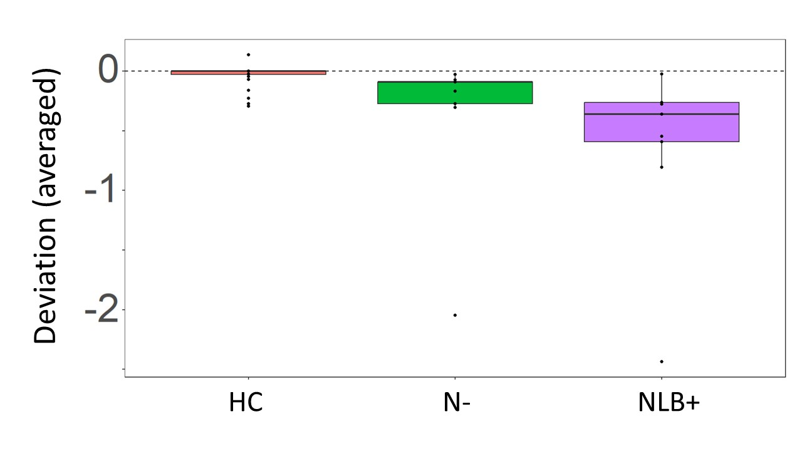

**Figure S10:** Verbal number bisection. The x-axis indicates the groups, and the y-axis reflects the relative deviation from the correct number. Black dots indicate individual participants’ mean responses.