**Additional file 5: Participants Perception of Training on Stratified Care**

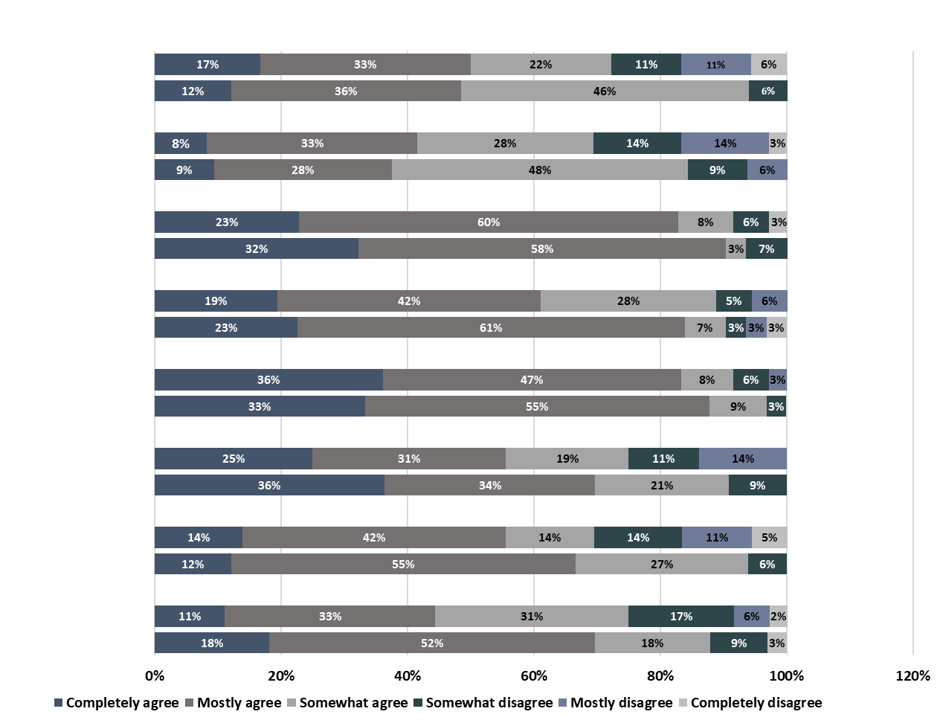

**The content in this**

**course was current**

**The relevance of the course**

**content offered was high**

**Additional helpful resources have been added**

**I rate my learning gain**

**from this course highly**

**The course was clearly structured**

**The learning objectives of the course were clearly defined**

**The course furthered my Interest in the subject**

**The material was appropriately illustrated**

**Class 2021**

**Class 2020**

**Class 2021**

**Class 2020**

**Class 2021**

**Class 2020**

**Class 2021**

**Class 2020**

**Class 2021**

**Class 2020**

**Class 2021**

**Class 2020**

**Class 2021**

**Class 2020**

**Class 2021**

**Class 2020**

**LEGEND: Class2020; First cohort, Class2021; Second cohort**