Energy efficiency trade-offs in small to large electric vehicles

Martin Weiss, Kira Christina Cloos, Eckard Helmers

Additional file
Table S1 of the Supplementary Material is an Excel sheet containing the raw data of vehicle attributes.
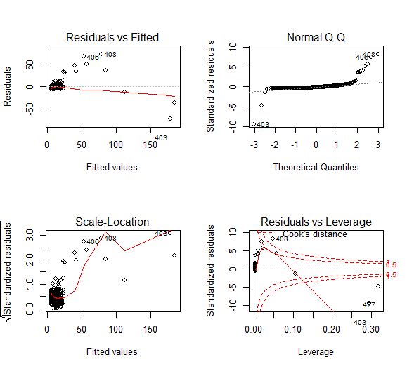
Figure S1: Diagnostic residuals plot - Model 1, certified energy consumption

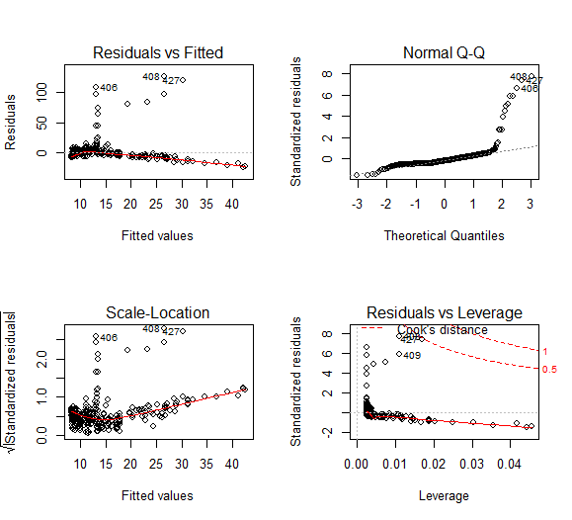
Figure S2: Diagnostic residuals plot - Model 2, certified energy consumption
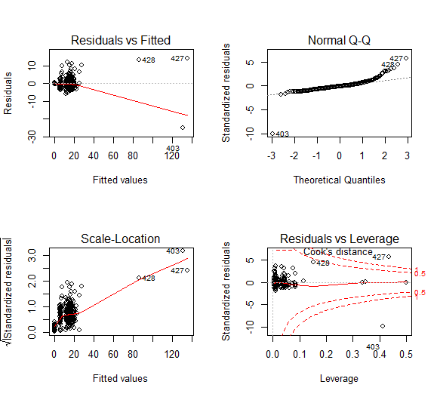
Figure S3: Diagnostic residuals plot - Model 3, certified energy consumption

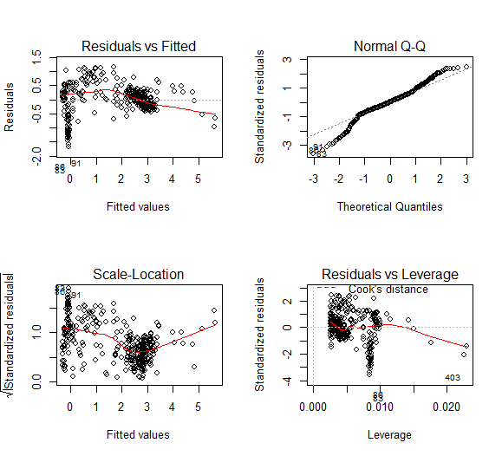
Figure S4: Diagnostic residuals plot - Model 4, certified energy consumption
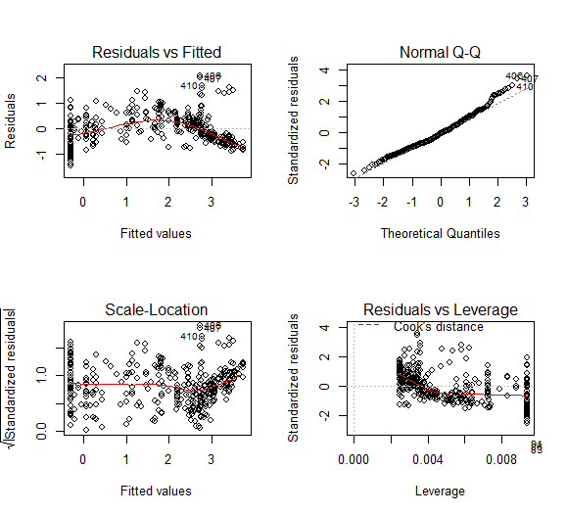
Figure S5: Diagnostic residuals plot - Model 5, certified energy consumption
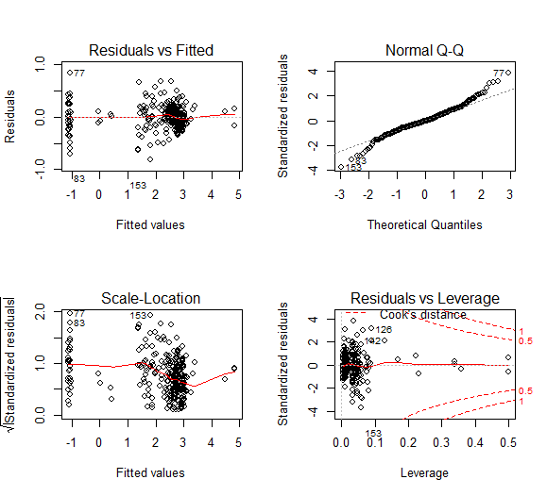

Figure S6: Diagnostic residuals plot - Model 6, certified energy consumption
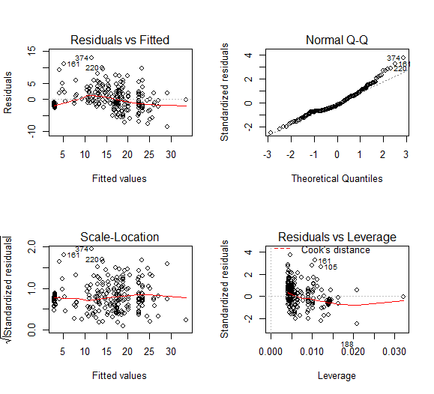
Figure S7: Diagnostic residuals plot - Model 1, real-word energy consumption
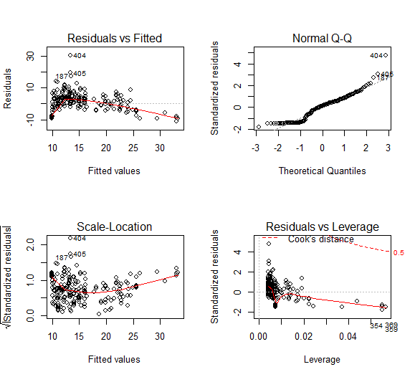
Figure S8: Diagnostic residuals plot - Model 2, real-world energy consumption
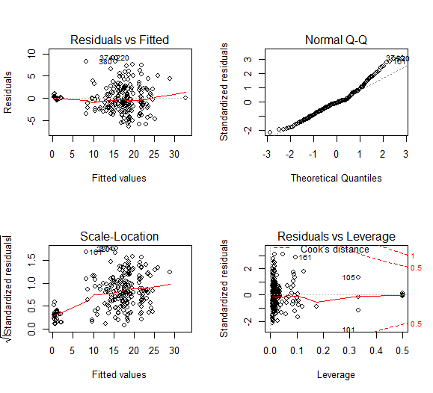
Figure S9: Diagnostic residuals plot - Model 3, real-world energy consumption
Figure S10: Diagnostic residuals plot - Model 4, real-world energy consumption
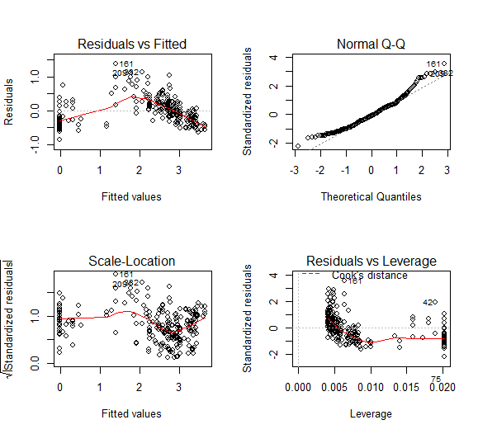
Figure S11: Diagnostic residuals plot - Model 5, real-world energy consumption
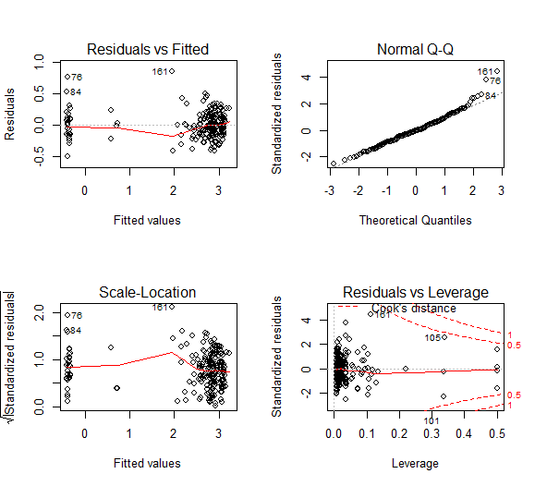
Figure S12: Diagnostic residuals plot - Model 6, real-world energy consumption
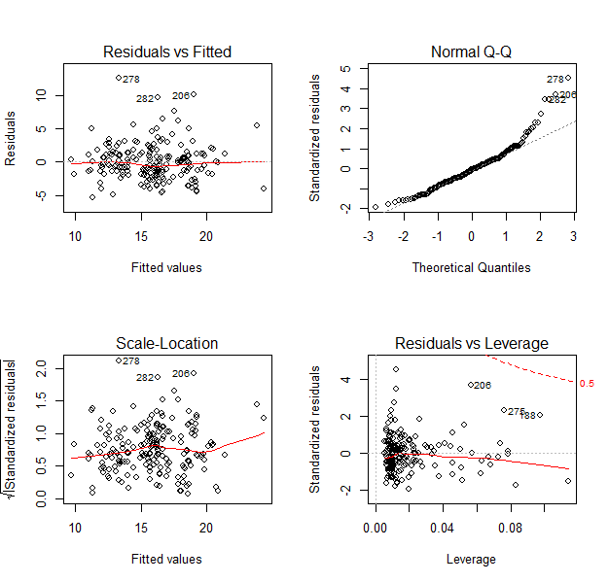
Figure S13: Diagnostic residuals plot - Model 3, certified energy consumption of passenger cars
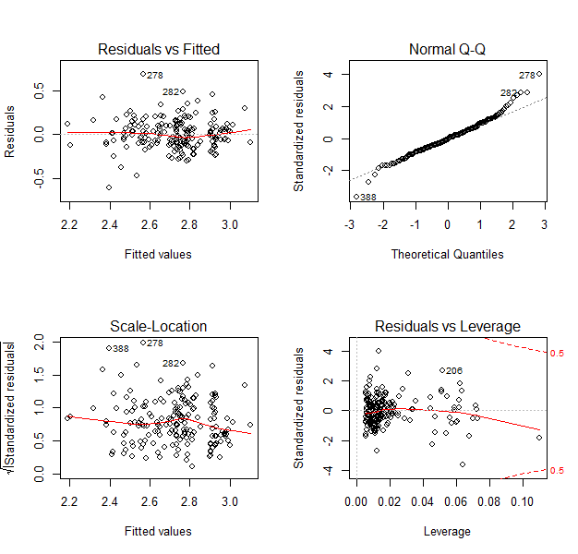
Figure S14: Diagnostic residuals plot - Model 6, certified energy consumption of passenger cars
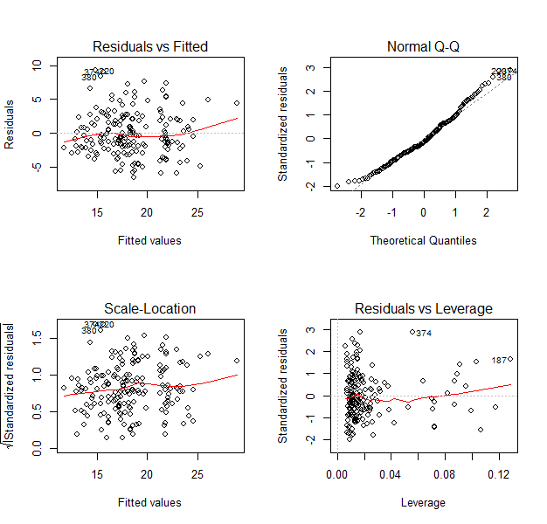
Figure S15: Diagnostic residuals plot - Model 3, real-world energy consumption of passenger cars
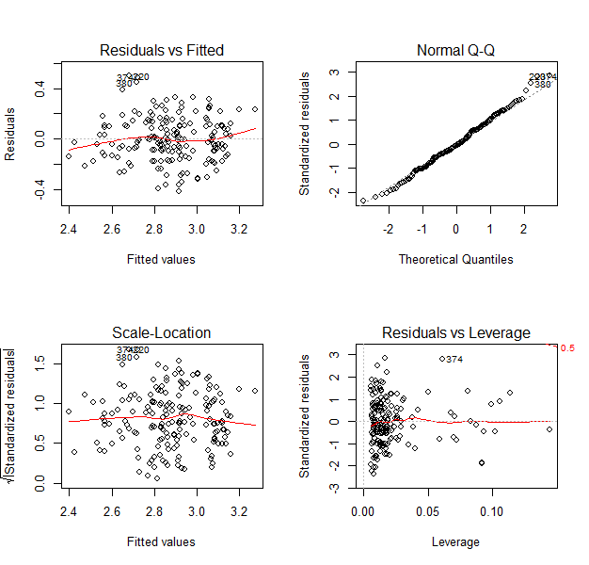
Figure S16: Diagnostic residuals plot - Model 6, real-world energy consumption of passenger cars
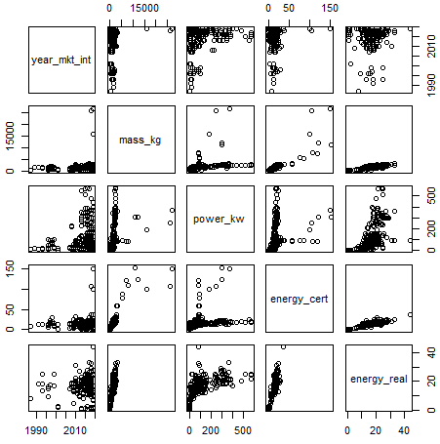
Figure S17: Pairplot - all electric vehicles captured in our analysis; year_mkt_int - year of market introduction, mass_kg - vehicle mass [kg], power_kw - rated motor power [kW], energy_cert - certified energy consumption [kWh/100 km], energy_real - real-world energy consumption [kWh/100 km]

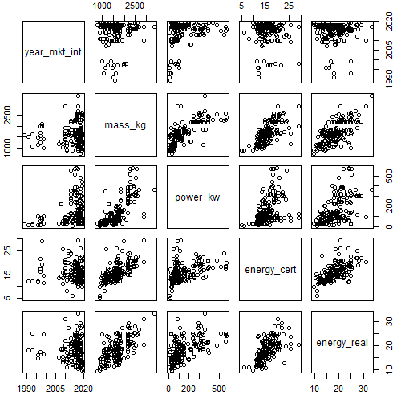
Figure S18: Pairplot - electric passenger cars; year_mkt_int - year of market introduction, mass_kg - vehicle mass [kg], power_kw - rated motor power [kW], energy_cert - certified energy consumption [kWh/100 km], energy_real - real-world energy consumption [kWh/100 km]

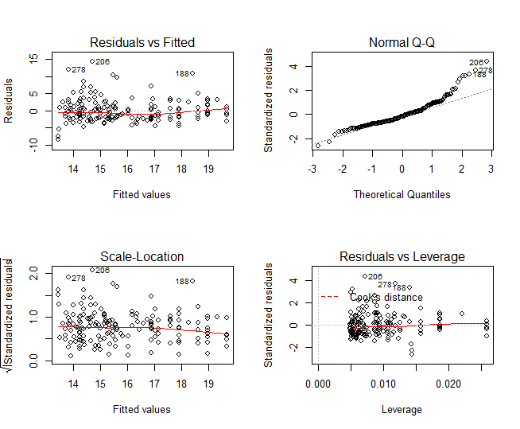
Figure S19: Diagnostic residuals plot - regression analysis of certified energy consumption of passenger cars as a function of battery capacity
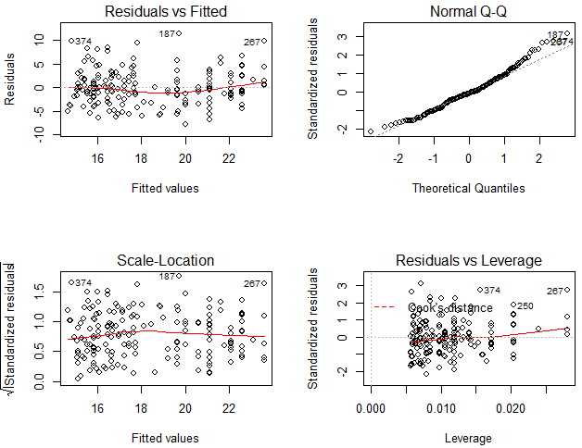
Figure S20: Diagnostic residuals plot - regression analysis of real-world energy consumption of passenger cars as a function of battery capacity
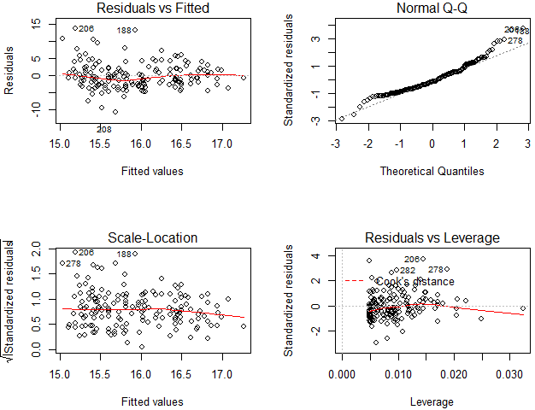
Figure S21: Diagnostic residuals plot - regression analysis of certified energy consumption of passenger cars as a function of (certified) drive range
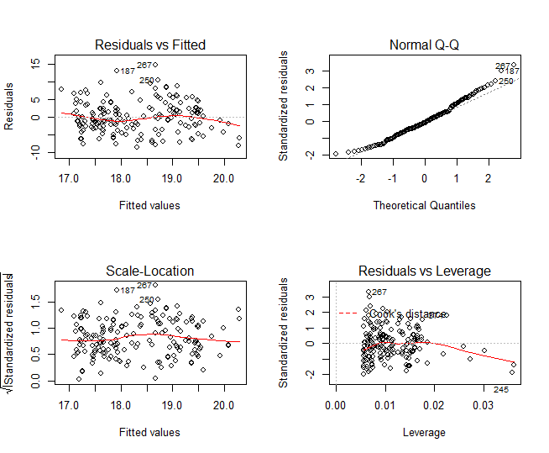
Figure S22: Diagnostic residuals plot - regression analysis of real-world energy consumption of passenger cars as a function of (real-world) drive range
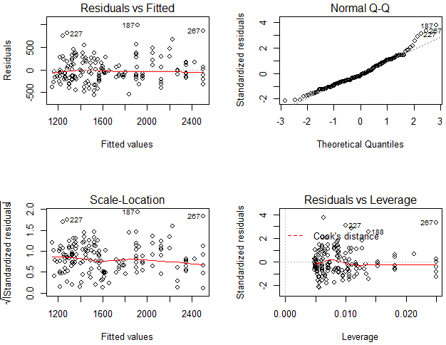
Figure S23: Diagnostic residuals plot - regression analysis of the mass of passenger cars as a function of battery capacity
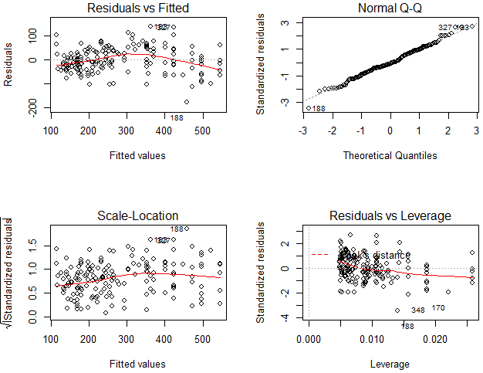
Figure S24: Diagnostic residuals plot - regression analysis of drive range of passenger cars (certified energy consumption) as a function of battery capacity
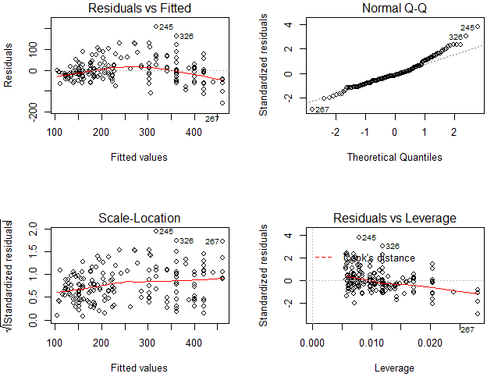
Figure S25: Diagnostic residuals plot - regression analysis of drive range of passenger cars (real-world energy consumption) as a function of battery capacity
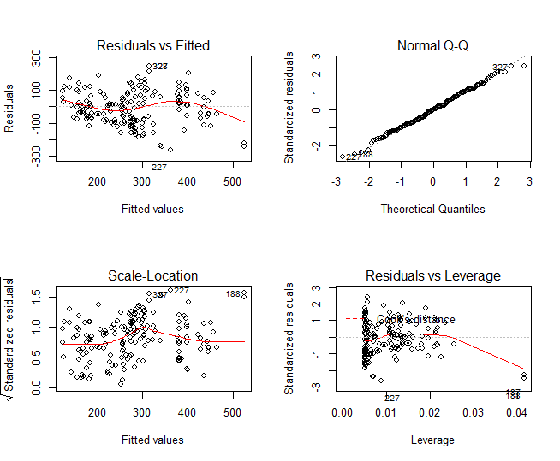
Figure S26: Diagnostic residuals plot - regression analysis of drive range (based on certified energy consumption) of passenger cars as a function of vehicle mass
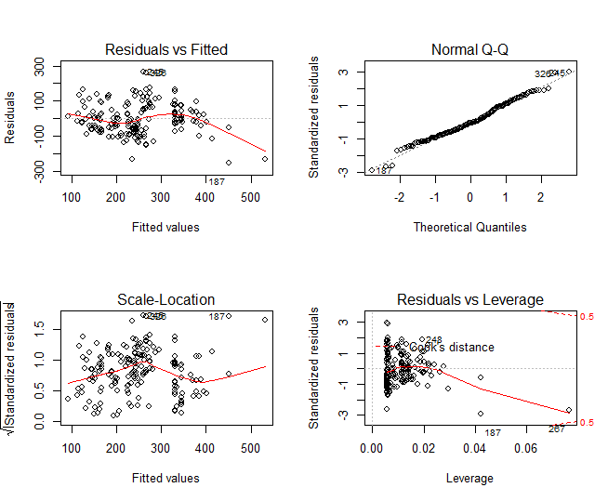
Figure S27: Diagnostic residuals plot - regression analysis of drive range (based on real-world energy consumption) of passenger cars as a function of vehicle mass
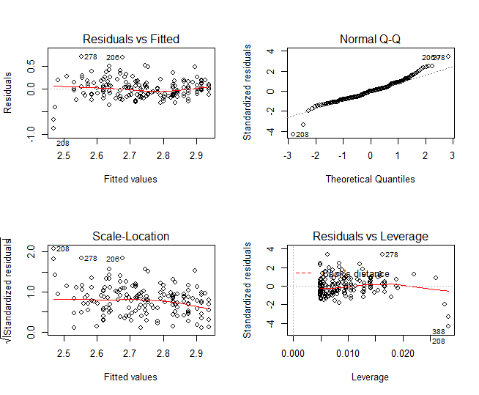
Figure S28: Diagnostic residuals plot - regression analysis of log(certified energy consumption) of passenger cars as a function of log(battery capacity)
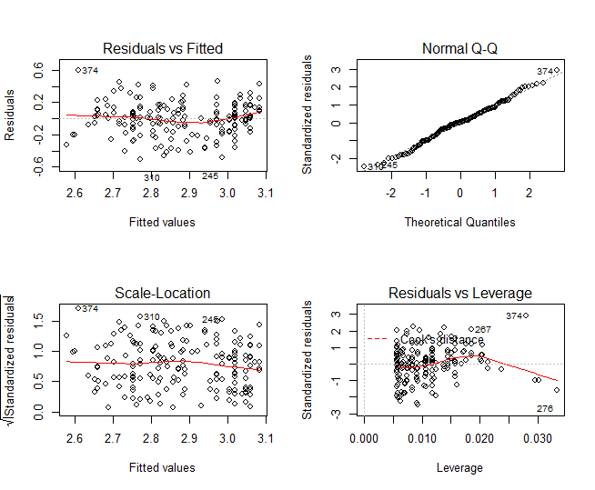
Figure S29: Diagnostic residuals plot - regression analysis of log(real-world energy consumption) of passenger cars as a function of log(battery capacity)
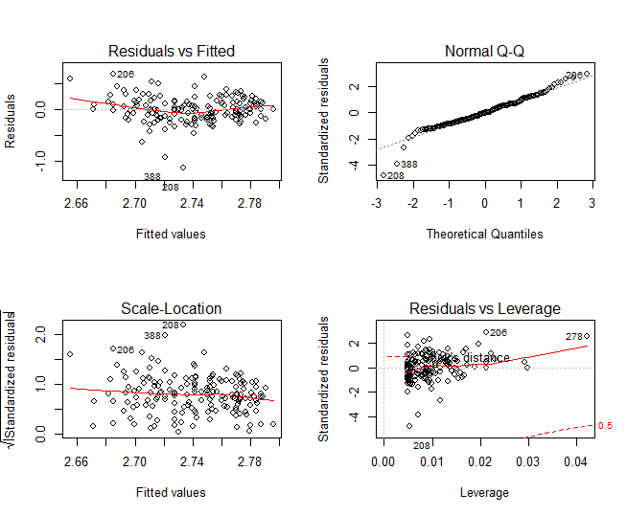
Figure S30: Diagnostic residuals plot - regression analysis of log(certified energy consumption) of passenger cars as a function of log(drive range, assuming certified energy consumption)
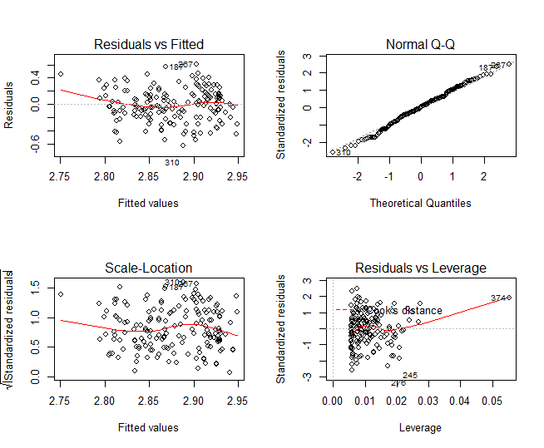
Figure S31: Diagnostic residuals plot - regression analysis of log(real-world energy consumption) of passenger cars as a function of log(drive range, assuming real-world energy consumption)
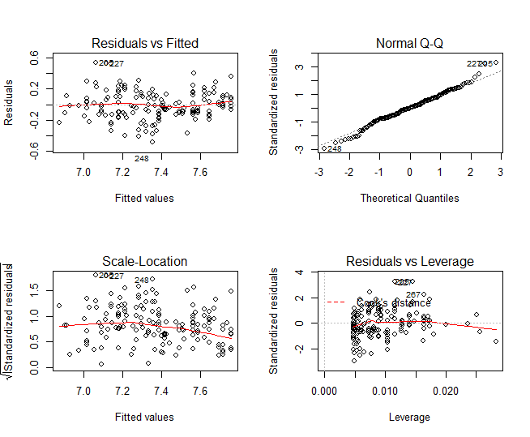
Figure S32: Diagnostic residuals plot - regression analysis of log(vehicle mass) of passenger cars as a function of log(battery capacity)
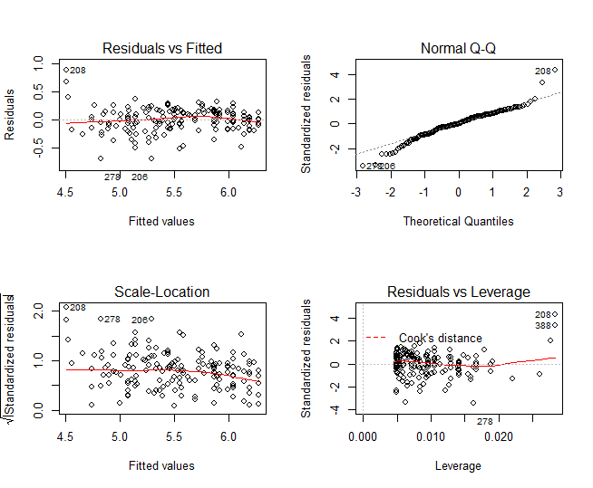
Figure S33: Diagnostic residuals plot - regression analysis of log(drive range, assuming certified energy consumption) of passenger cars as a function of log(battery capacity)
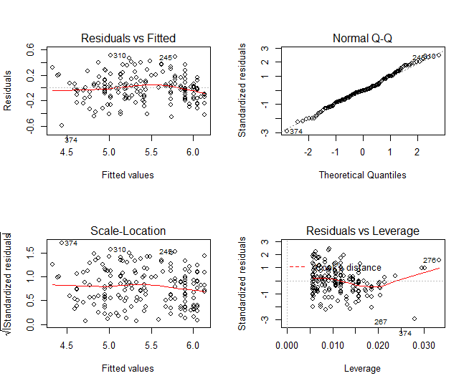
Figure S34: Diagnostic residuals plot - regression analysis of log(drive range, assuming real-world energy consumption) of passenger cars as a function of log(battery capacity)
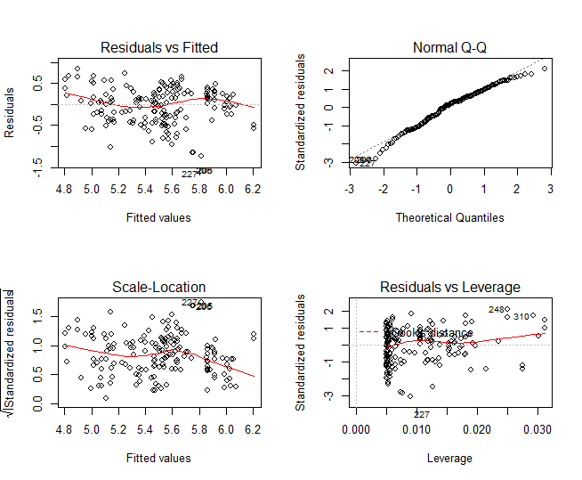
Figure S35: Diagnostic residuals plot - regression analysis of log(drive range, assuming certified energy consumption) of passenger cars as a function of log(vehicle mass)
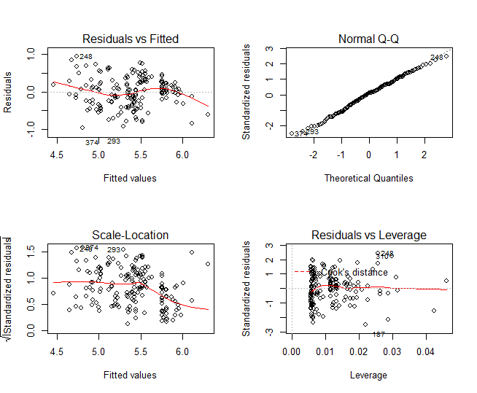
Figure S36: Diagnostic residuals plot - regression analysis of log(drive range, assuming real-world energy consumption) of passenger cars as a function of log(vehicle mass)

Table S2: Regression analysis - certified and real-world energy consumption, vehicle mass, battery capacity, and drive range of electric passenger cars; significance at 1% level (***), 5% level (**), and 10% level (*)
Energy consumption | Coefficient | Value | Standard error | t value |  | Pr (>abs t) | p value |  | Adjusted R²
 | energy consumption = α₇+β₁₃battery capacity
Certified | (Intercept)*** | 13 | 0.51 | 25 |  | 6.10e-64 | <0.001 |  | 0.22
 | Battery capacity*** | 6.97e-02 | 8.42e-03 | 8.28 |  | 1.64e-14
Real-world | (Intercept)*** | 14 | 0.55 | 25 |  | 3.66e-19 | <0.001 |  | 0.34
 | Battery capacity*** | 9.91e-02 | 1.02e-02 | 6.26 |  | 1.52e-03
 | energy consumption = α₇+β₁₃drive range
Certified | (Intercept)*** | 15 | 0.69 | 21 |  | 3.40e-54 | 0.032 |  | 0.02
 | Drive range** | 4.10e-03 | 1.90e-03 | 2.16 |  | 3.24e-02
Real-world | (Intercept)*** | 17 | 0.72 | 23 |  | 3.99e-55 | 0.008 |  | 0.03
 | Drive range*** | 7.12e-03 | 2.64e-03 | 2.70 |  | 7.68e-03
 | mass = α₈+β₁₄battery capacity
 | (Intercept*** | 999 | 37 | 27 | 2.46e-70 |  | <0.001 | 0.69
 | Battery capacity*** | 15.0 | 0.6 | 22 | 3.29e-55
 | drive range = α₈+β₁₄battery capacity
Certified | (Intercept)*** | 63 | 6 | 9 | 3.21e-19 |  | <0.001 | 0.85
 | Battery capacity*** | 4.8 | 0.1 | 33 | 3.71e-83
Real-world | (Intercept)*** | 66 | 7 | 10 | 4.44e-18 |  | <0.001 | 0.79
 | Battery capacity*** | 3.9 | 0.2 | 24 | 2.19e-58
 | drive range = α₉+β₁₅mass
Certified | (Intercept)** | -54 | 27 | -2.00 | 4.72e-02 |  | <0.001 | 0.44
 | Mass*** | 0.20 | 1.63e-2 | 12 | 6.57e-26
Real-world | (Intercept) | -33 | 27 | -1.21 | 0.23 |  | <0.001 | 0.45
 | Mass*** | 0.17 | 1.65e-2 | 10 | 3.11e-19
 | log(energy consumption) = α₇+β₁₃log(battery capacity)
Certified | (Intercept)*** | 1.97 | 0.12 | 17 |  | 6.57e-41 | <0.001 |  | 0.26
 | log(Battery capacity)*** | 0.21 | 2.96e-02 | 7 |  | 2.15e-11
Real-world | (Intercept)*** | 2.08 | 9.70e-02 | 21 |  | 6.61e-51 | <0.001 |  | 0.29
 | log(Battery capacity)*** | 0.22 | 2.53e-03 | 9 |  | 4.26e-15
 | log(energy consumption) = α₇+β₁₃log(rive range)
Certified | (Intercept)*** | 2.40 | 0.19 | 12 |  | 1.41e-26 | 0.070 |  | 0.01
 | log(Drive range)* | 6.15e-02 | 3.38e-03 | 1.82 |  | 7.01e-02
Real-world | (Intercept)*** | 2.44 | 0.19 | 13 |  | <2e-16 | 0.020 |  | 0.02
 | log(drive range)** | 8.14e-02 | 3.48e-02 | 2.34 |  | 2.04e-02
 | log(mass) = α₈+β₁₄log(battery capacity)
 | (Intercept*** | 5.99 | 6.87e-02 | 87 | 4.01e-165 |  | <0.001 | 0.67
 | Battery capacity*** | 0.38 | 1.75e-02 | 22 | 8.14e-56
 | log(drive range) = α₈+β₁₄log(battery capacity)
Certified | (Intercept)*** | 2.63 | 0.12 | 23 | 9.95e-58 |  | <0.001 | 0.84
 | log(Battery capacity)*** | 0.79 | 2.96e-02 | 27 | 1.34e-68
Real-world | (Intercept)*** | 2.53 | 9.70e-02 | 26 | 2.67e-62 |  | <0.001 | 0.84
 | log(Battery capacity)*** | 0.78 | 2.53e-2 | 31 | 6.444-73
 | log(drive range) = α₉+β_{15l}log(mass)
Certified | (Intercept)*** | -3.23 | 0.78 | -4.14 | 5.24e-05 |  | <0.001 | 0.38
 | log(Mass)*** | 1.18 | 0.10 | 11.3 | 4.16e-23
Real-world | (Intercept)*** | -3.81 | 0.81 | -4.73 | 4.64e-06 |  | <0.001 | 0.45
 | log(Mass)*** | 1.25 | 0.11 | 11.6 | 2.73e-23

Table S3: Sensitivity analysis - regression analysis of medians per vehicle type; significance at 1% level (***), 5% level (**), and 10% level (*); light-commercial and heavy-duty vehicles are excluded from the regression analysis of real-world fuel consumption in Model 6 as sample size is insufficient; Models 3 and 6 include vehicle type as categorical variable
Energy consumption | Coefficient |  | Value |  | Standard error |  | t value |  | Pr (>abs t) | p value |  | Adjusted R²
 | Model 1: energy consumption = α₁+β₁mass
Certified | (Intercept) | 0.30 |  |  |  | 0.59 | 0.50 |  | 0.64 | <0.001 |  | 0.97
 | Mass*** | 1.04e-02 |  |  |  | 1.07e-03 | 9.66 |  | 2.02e-04
Real-world | (Intercept) | 1.44 |  |  |  | 1.41 | 1.02 |  | 0.35 | 0.002 |  | 0.91
 | Mass*** | 1.27e-02 |  |  |  | 2.02e-03 | 6.26 |  | 1.52e-03
 | Model 2: energy consumption = α₂+β₂power
Certified | (Intercept | 1.56 |  |  |  | 1.12 | 1.39 | 0.22 |  | 0.06 | 0.71
 | Power* | 0.18 |  |  |  | 7.41e-02 | 2.41 | 6.08e-02
Real-world | (Intercept) | 3.02 |  |  |  | 1.62 | 1.86 | 0.12 |  | 0.10 | 0.65
 | Power* | 0.22 |  |  |  | 0.11 | 2.04 | 9.67e-02
 | Model 3: energy consumption = α₃+β₃mass+ β₄power + β₅year + β₆type
Certified | (Intercept) |  |  | 125 |  | 199 | 0.63 | 0.59 |  | 0.04 | 0.94
 | Mass |  |  | 1.10e-02 |  | 3.85e-03 | 2.87 | 0.10
 | Power |  |  | -3.04e-02 |  | -6.30e-02 | -0.48 | 0.68
 | Year |  |  | -6.24e-02 |  | 9.91e-02 | -0.63 | 0.59
 | Type |  |  | 0.41 |  | 0.91 | 0.45 | 0.69
Real-world | (Intercept) |  |  | 240 |  | 429 | 0.56 | 0.63 |  | 0.11 | 0.83
 | Mass |  |  | 1.23e-02 |  | 8.22e-03 | 1.50 | 0.76
 | Power |  |  | -4.79e-02 |  | 0.13 | -0.36 | 0.76
 | Year |  |  | -1.12 |  | 0.21 | -0.56 | 0.63
 | Type |  |  | 1.33 |  | 1.92 | 0.69 | 0.56
 | Model 4: log(energy consumption) = α₄+β₇log(mass)
log(Certified) | (Intercept)*** |  |  | -5.09 |  | 1.05 | -4.84 | 4.72e-03 |  | <0.001 | 0.87
 | log(Mass)*** |  |  | 1.08 |  | 0.15 | 7.22 | 7.96e-04
log(Real-world) | (Intercept)*** |  |  | -3.94 |  | 0.94 | -4.19 | 8.61e-03 |  | <0.001 | 0.85
 | log(Mass)*** |  |  | 0.96 |  | 0.14 | 7.05 | 8.90e-04
 | Model 5: log(energy consumption) = α₅+β₈log(power)
log(Certified) | (Intercept) |  |  | 3.48e-02 |  | 0.24 | 0.15 | 0.89 |  | <0.001 | 0.92
 | log(Power)*** |  |  | 0.61 |  | 7.88e-02 | 7.68 | 5.96e-04
log(Real-world) | (Intercept)* |  |  | 0.60 |  | 0.24 | 2.47 | 5.67e-02 |  | <0.001 | 0.90
 | log(Power)*** |  |  | 0.54 |  | 7.58e-02 | 7.16 | 8.27e-04
 | Model 6: log(energy consumption) = α₆+β₉log(mass)+ β₁₀log(power)+ β₁₁year +β₁₂type
log(Certified) | (Intercept) |  |  | -51 |  | 146 | -0.35 | 0.76 |  | 0.06 | 0.90
 | log(Mass) |  |  | 0.83 |  | 0.58 | 1.44 | 0.29
 | log(Power) |  |  | 0.37 |  | 0.16 | 2.32 | 0.15
 | Year |  |  | 2.36e-02 |  | 7.18e-02 | 0.33 | 0.77
 | Type |  |  | -0.26 |  | 0.50 | -0.52 | 0.66
log(Real-world) | (Intercept) |  |  | -64 |  | 152 | -0.42 | 0.71 |  | 0.07 | 0.86
 | log(Mass) |  |  | 0.30 |  | 0.63 | 0.47 | 0.68
 | log(Power) |  |  | 0.44 |  | 0.17 | 2.56 | 0.13
 | Year |  |  | 3.17e-02 |  | 7.47e-02 | 0.42 | 0.71
 | Type |  |  | -6.63e-02 |  | 0.53 | -0.13 | 0.91

