SUPPLEMENTARY MATERIAL

TABLE 1: Proximate composition and sugar monomers of the galactomannans used in the present study. Different letters between the row indicate a significant difference (p < 0.05) according to Tukey’s post hoc means comparison test.
 | Fenugreek gum | Alfalfa gumª | Locust bean gum
Proximate composition¹ (g 100g⁻¹)
Total carbohydrates | 97.2 ± 0.6b | 96.7 ± 1.2b | 94.0 ± 0.6a
Protein | 1.9 ± 0.4b | 1.3 ± 0.1a | 2.2 ± 0.1b
Ash | 0.85 ± 0.2a | 2.0 ± 0.2b | 3.9 ± 0.5c
Sugar monomers composition (g 100g⁻¹ of total carbohydrate matter)
Arabinose | nd | 0.20 ± 0.0 | nd
Galactose | 47.7 ± 0.1b | 46.0 ± 2.8c | 21.7 ± 0.3a
Glucose | 0.1 ± 0.0a | 0.30 ± 0.0b | 0.6 ± 0.0c
Mannose | 52.1± 0.1a | 53.8 ± 3.0a | 77.7 ± 0.3b
Fucose | nd | nd | nd
Rhamnose | nd | nd | nd
Uronic acids | nd | nd | nd
M/G | 1.09 ± 0.01a | 1.18 ± 0.14a | 3.56 ± 0.06b
ª data from (Hellebois et al., 2021)
¹Expressed on dry basis, lipids detected in traces.

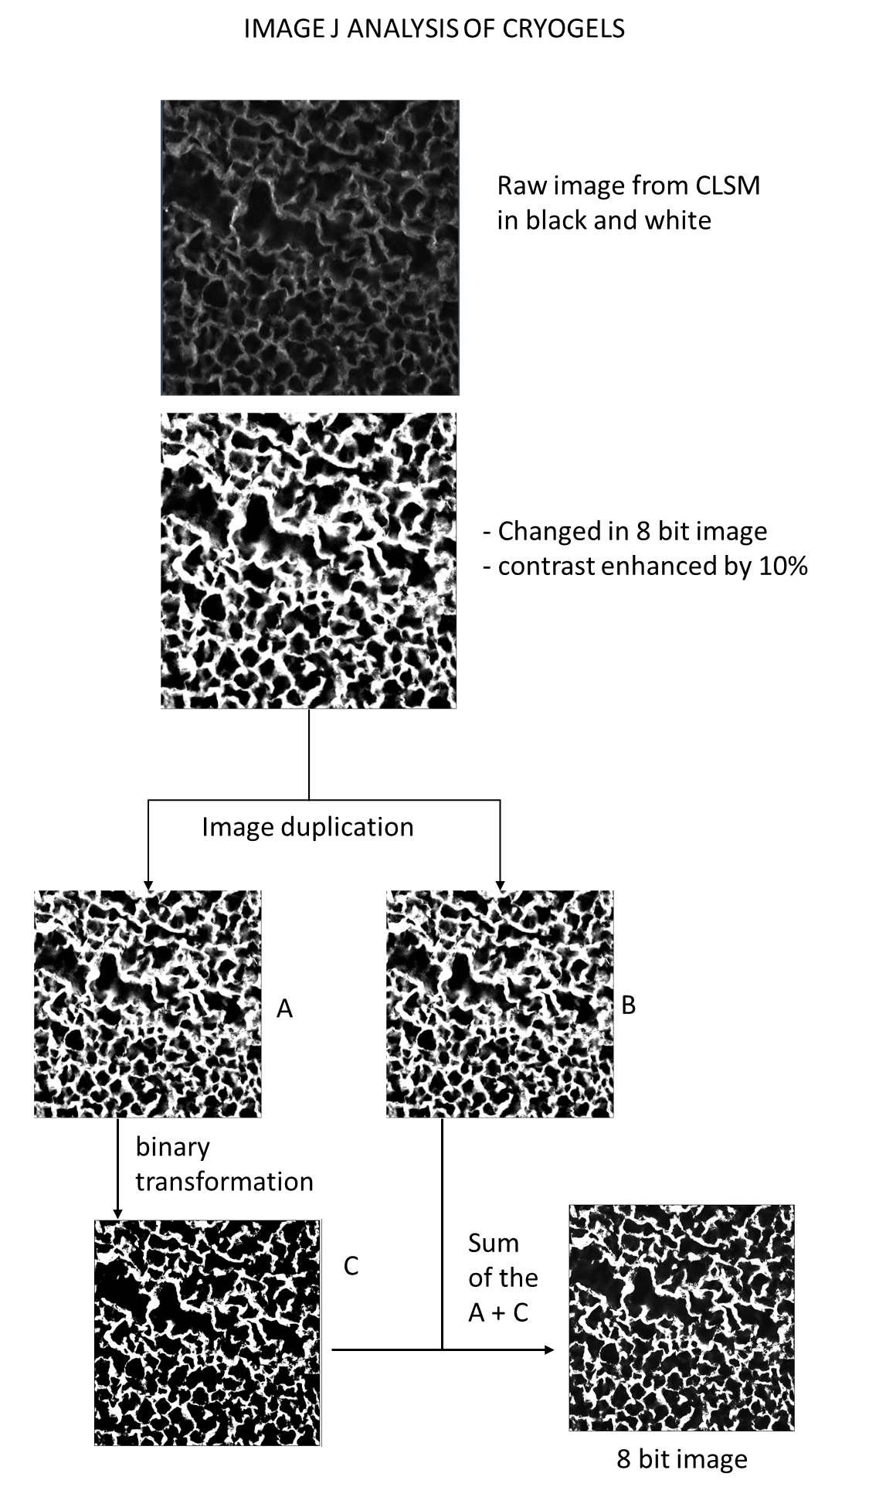
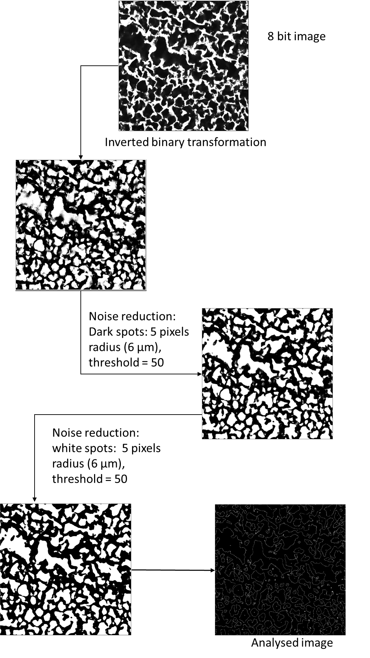
SUPPLEMENTARY FIGURE 1: Methodology employed to characterize the macroporous network of the cryogel using Image J software.

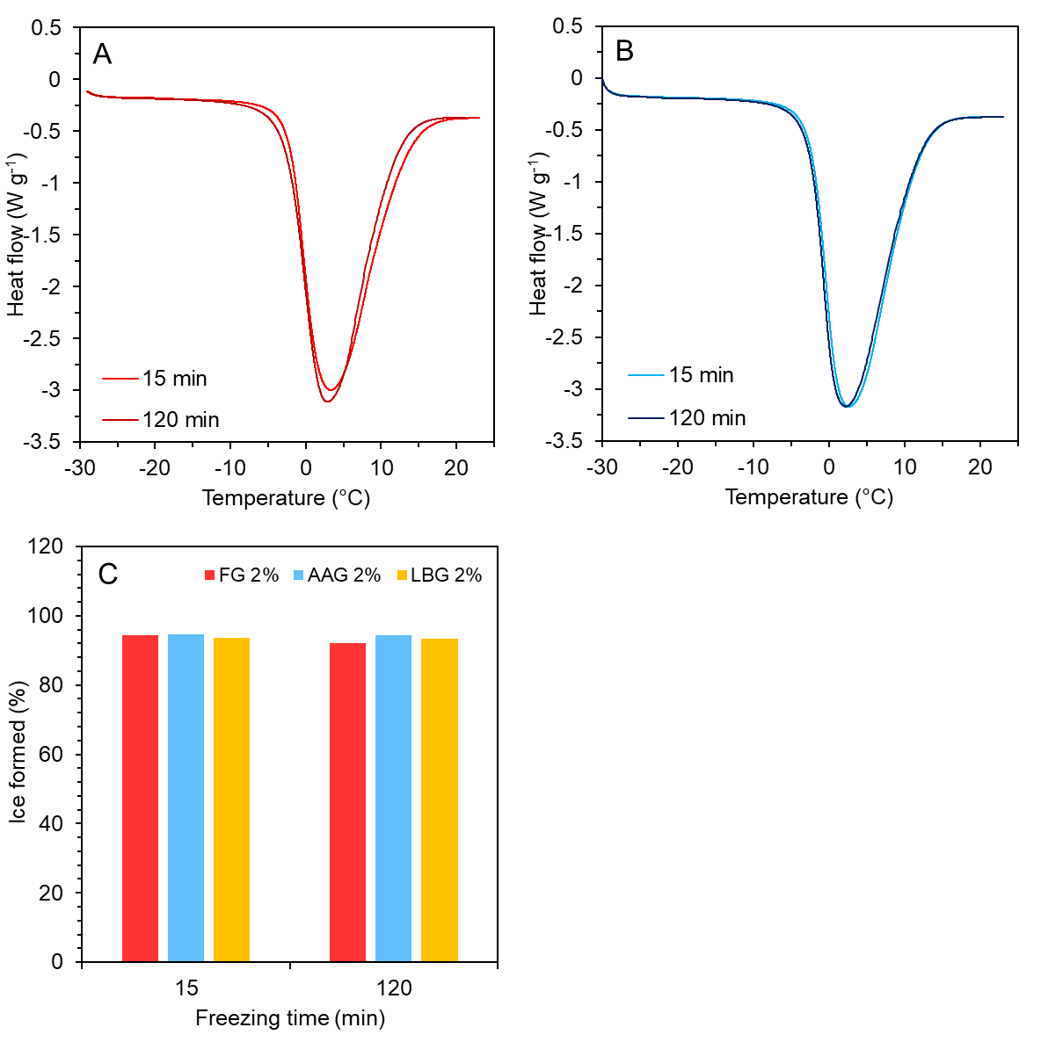

SUPPLEMENTARY FIGURE 2: DSC thermographs illustrating the melting profile of FG (A) and AAG (B) (2% wt) cryogels as influenced by the cryogenic processing duration. The cryogels were obtained after a single freeze-thaw cycle (from 25 to -30 to 25 °C). In figure 2C, the amount of ice formed during the cryogenic process is given.

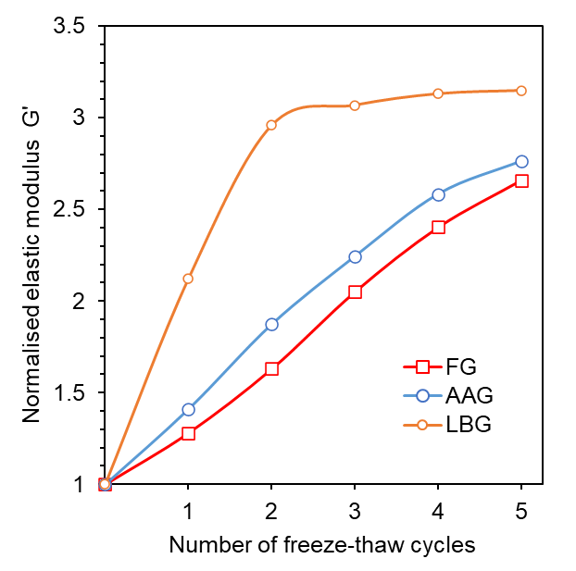
SUPPLEMENTARY FIGURE 3: Effect of freeze-thaw cycling on the normalized (to the galactomannan solution) elastic modulus (G′) values measured at 25 °C (strain 0.5%, f = 1 Hz).

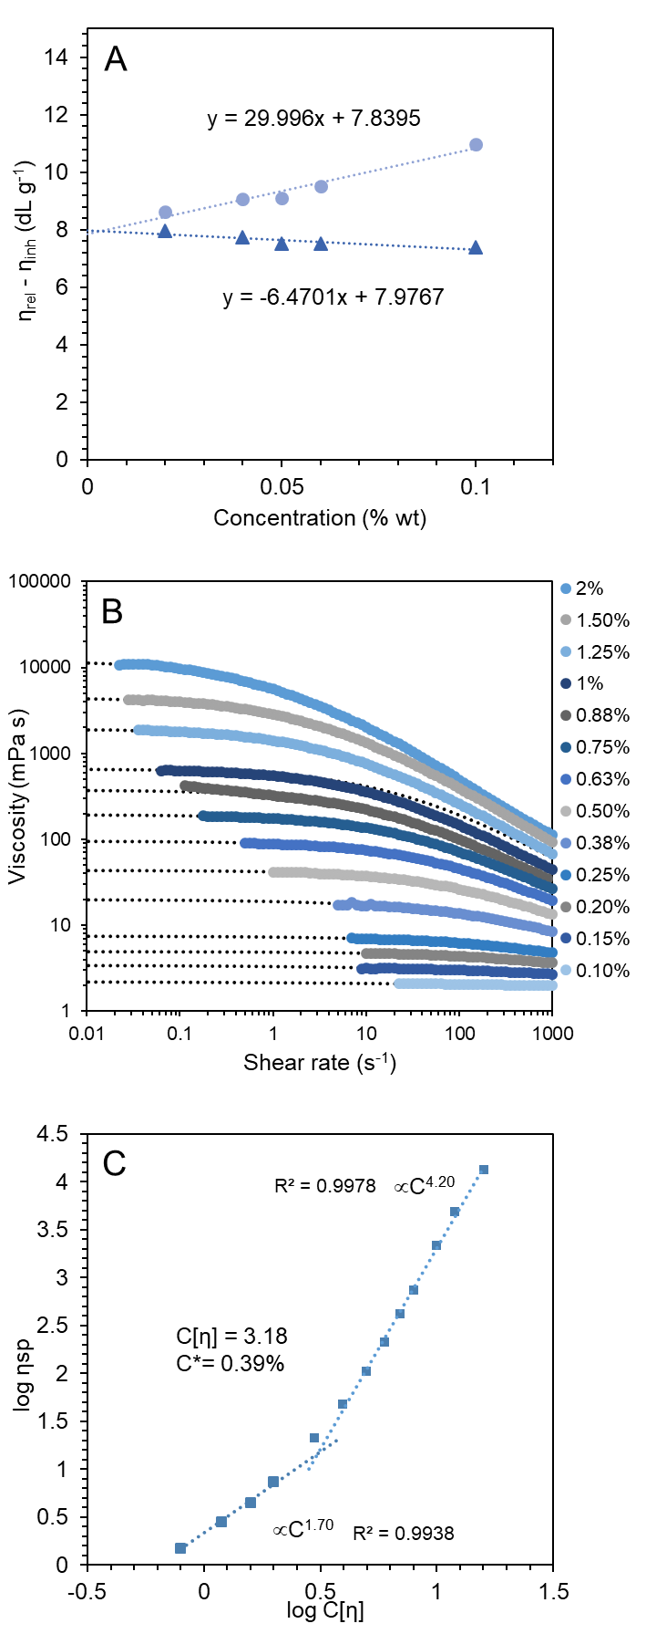
SUPPLEMENTARY FIGURE 4: Inherent (Kraemer) and relative (Huggins) viscosity as a function of fenugreek concentration at 25 °C (A), flow behaviour curves of fenugreek gum dispersion as influenced by gum concentration (B); double logarithmic plot of specific viscosity at zero shear rate (η_{sp,0}) as a function of coil overlap parameter C[η] at 25 °C (C).

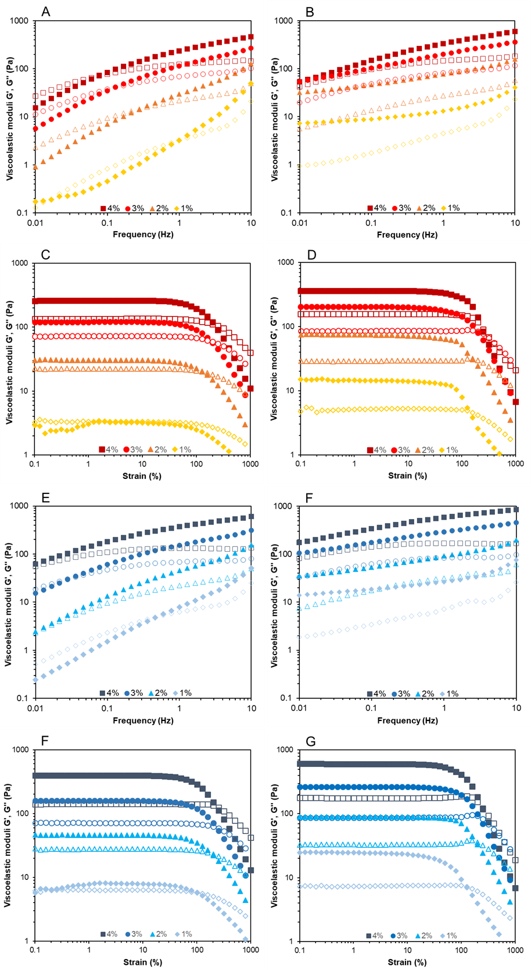
SUPPLEMENTARY FIGURE 5: Influence of FG (A-D) and AAG (E-G) biopolymer concentration (1-4% wt) on the frequency (A-B, E-F; strain = 0.5%) and amplitude (C-D, F-G; f = 1 Hz) sweeps rheological spectra (at 25 °C).
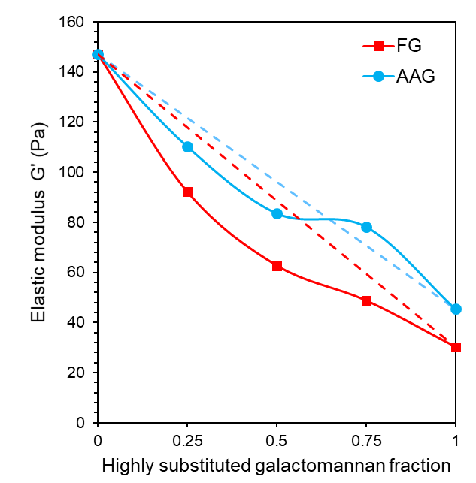
SUPPLEMENTARY FIGURE 6: Elastic modulus of binary blend of AAG or FG with LBG at different ratios (2% wt biopolymer). Dashed lines represent the theorical values of an ideal physical binary galactomannan blend.

