SUPPLEMENTARY MATERIAL

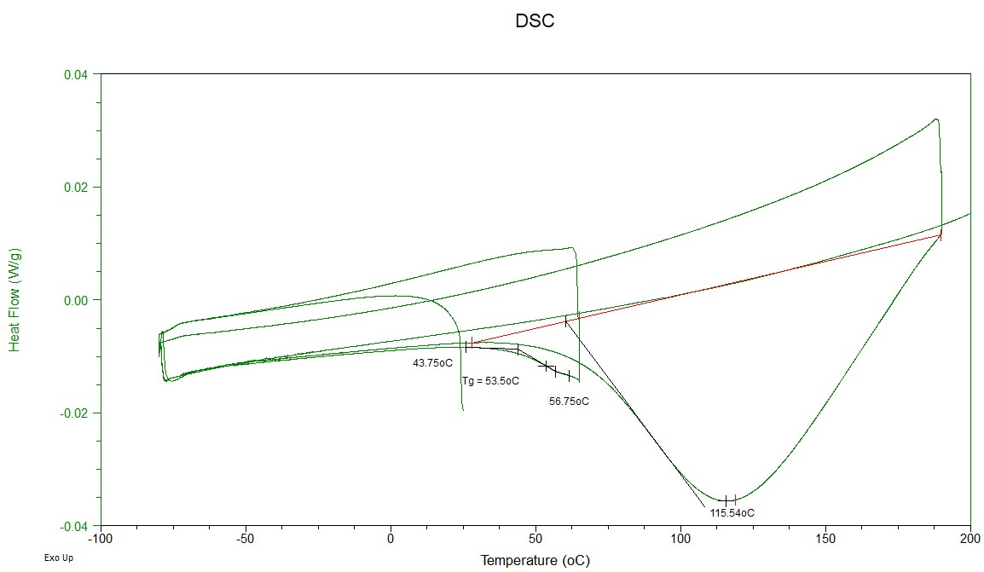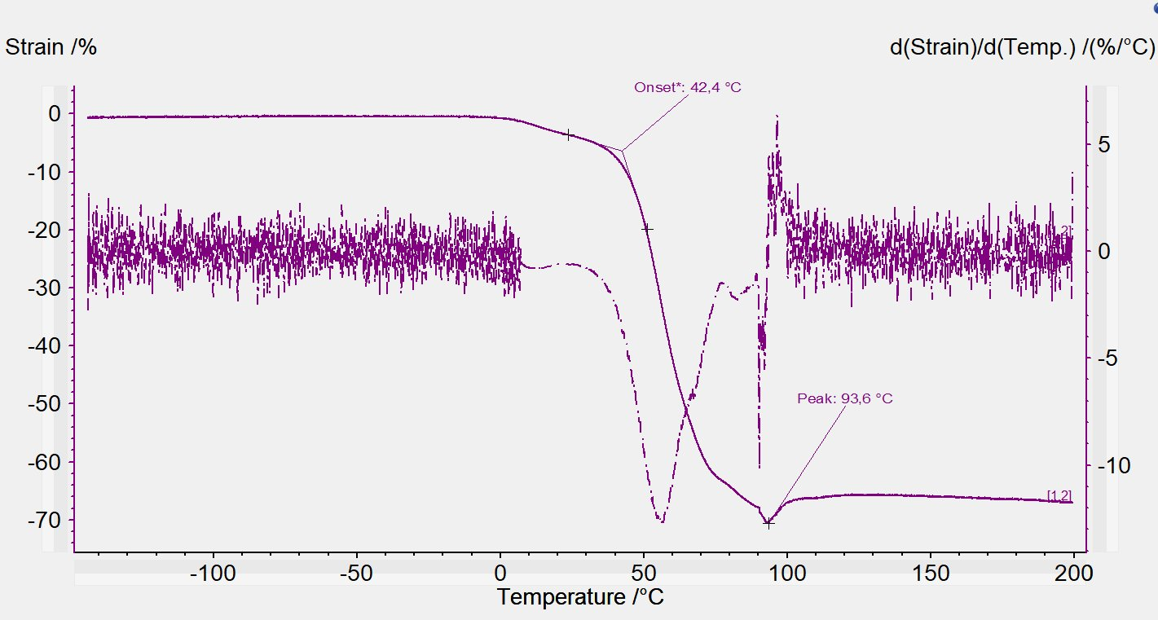
A
B
SUPPLEMENTARY FIGURE 1: Indicative Differential Scanning Calorimetry (DSC; A) and Thermo Mechanical Analysis (TMA) spectra (B) of flaxseed gum extract.

