Supplementary Material
Box 1 - Background on passenger car registrations in Germany
Together, some 350,000 Volkswagen Golf, Opel Astra, and Ford Focus were registered in Germany in 2016 (Table S1). The three compact cars account for 10% of the German passenger car market (AMS, 1981-2004; KBA, 2017; VDA, 2017). The VW Golf outsells both the Opel Astra and the Ford Focus by more than a factor of two (Figure S1). Against a relatively stable German car market, the registrations of the Opel Kadett/Astra and Ford Escort/Focus have been declining since 2000. This observation suggests a shift in consumer preferences towards other compact car models or other types of passenger cars such as sport-utility vehicles (SUVs).

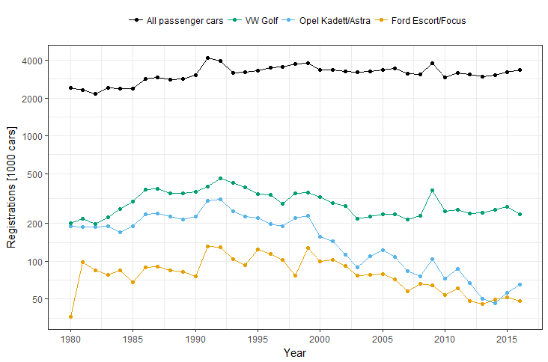
Figure S1: Yearly registrations of the three compact car models and all passenger cars in Germany between 1980 and 2016; Principal data source: AMS (1981-2004), KBA (2017), VDA (2017)

Table S1: Passenger car registrations in Germany between 1980 and 2016; Source: AMS (1981-2004), KBA (2017), VDA (2017)
Year | Volkswagen Golf [1000 cars] | Opel Kadett/Astra [1000 cars] | Ford Escort/Focus [1000 cars] | Sum [1000 cars] | Total passenger car registrations [1000 cars]
1980 | 200.892 | 190.504 | 36.159 | 427.555 | 2426
1981 | 219.382 | 188.488 | 99.192 | 507.062 | 2330
1982 | 198.401 | 188.112 | 84.871 | 471.384 | 2156
1983 | 224.887 | 189.993 | 77.880 | 492.760 | 2427
1984 | 260.229 | 171.718 | 84.164 | 516.111 | 2394
1985 | 298.175 | 190.124 | 67.891 | 556.190 | 2379
1986 | 371.382 | 236.120 | 89.245 | 696.747 | 2829
1987 | 378.856 | 239.929 | 90.976 | 709.761 | 2916
1988 | 346.599 | 226.487 | 84.862 | 657.948 | 2808
1989 | 349.777 | 214.528 | 82.686 | 646.991 | 2832
1990 | 358.364 | 227.002 | 76.433 | 661.799 | 3041
1991 | 395.093 | 302.095 | 131.707 | 828.895 | 4159
1992 | 455.613 | 310.388 | 129.235 | 895.236 | 3930
1993 | 423.199 | 251.050 | 103.759 | 778.008 | 3194
1994 | 387.814 | 228.186 | 93.683 | 709.683 | 3209
1995 | 342.135 | 220.104 | 123.979 | 686.218 | 3314
1996 | 337.550 | 198.384 | 114.746 | 650.680 | 3496
1997 | 289.182 | 191.254 | 102.531 | 582.967 | 3528
1998 | 347.149 | 220.095 | 77.338 | 644.582 | 3736
1999 | 355.646 | 229.756 | 127.316 | 712.718 | 3802
2000 | 327.341 | 157.936 | 99.400 | 584.677 | 3378
2001 | 293.219 | 144.183 | 102.106 | 539.508 | 3342
2002 | 274.162 | 112.494 | 92.255 | 478.911 | 3253
2003 | 218.227 | 89.5670 | 77.468 | 385.262 | 3237
2004 | 226.515 | 110.218 | 78.306 | 415.039 | 3267
2005 | 237.990 | 122.841 | 78.899 | 439.730 | 3342
2006 | 236.980 | 108.313 | 72.128 | 417.421 | 3468
2007 | 214.368 | 83.0480 | 57.546 | 354.962 | 3148
2008 | 231.293 | 76.0690 | 66.244 | 373.606 | 3090
2009 | 366.231 | 104.750 | 64.225 | 535.206 | 3807
2010 | 251.078 | 72.685 | 53.72 | 377.483 | 2916
2011 | 258.059 | 86.579 | 61.157 | 405.795 | 3174
2012 | 240.702 | 66.981 | 47.936 | 355.619 | 3083
2013 | 244.249 | 50.322 | 45.485 | 340.056 | 2952
2014 | 255.984 | 46.193 | 49.494 | 351.671 | 3037
2015 | 272.094 | 56.079 | 51.677 | 379.85 | 3206
2016 | 236.581 | 65.173 | 47.99 | 349.744 | 3339

Box 2 - Collection of data on the actual on-road fuel consumption of vehicles
In several cases the sample size of fuel consumption data for individual model variants obtained from Spritmonitor (2018a) is small (Figure S2). Whenever less than ten vehicle owners report their fuel consumption, averages for individual model variants may be biased. Moreover, vehicle data are often not specified at the level of detail that is sufficient to allocate fuel consumption data to a specific model variant. The collection of fuel consumption data and the matching of these data with individual car models and model groups therefore required expert judgment and introduces a random error into our analysis which we discuss in Section 4.1 of the article.

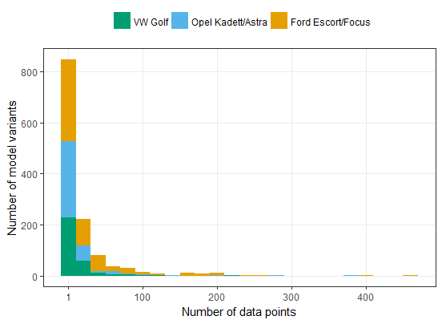
Figure S2: Frequency distribution of fuel consumption data as obtained from Spritmonitor (2018a) for model variants running on gasoline and diesel; fuel consumption data are available for 1,289 out of the 2,218 model variants initially identified

Box 3: Overview – Car models covered in the sensitivity analysis
- Audi A3
- BMW 3-series
- Ford Fiesta
- Ford Focus
- Mercedes C-class
- Opel Corsa
- Opel Astra
- Seat Cordoba
- Seat Leon
- Skoda Fabia
- Skoda Octavia
- Volkswagen Golf
- Volkswagen Passat
- Volkswagen Polo

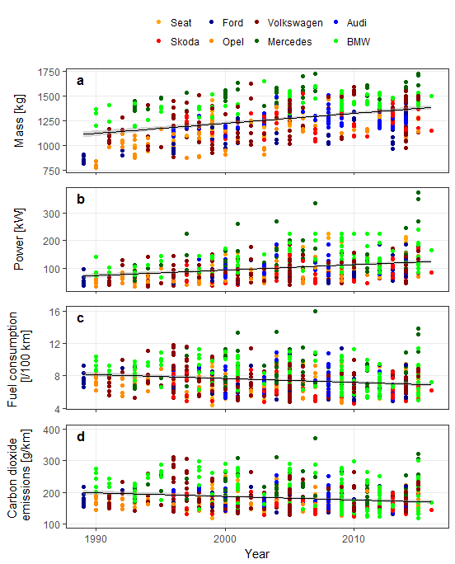
Figure S3: Sensitivity analysis - Time series of mass (a), power (b), on-road fuel consumption (c), and on-road CO₂ emissions and of selected car models sold in Germany; shaded areas represent the 95%-confidence intervals of the fitted regression line; data on front area were not collected; Data source: Irrgang (2018) based on Spritmonitor (2018a)

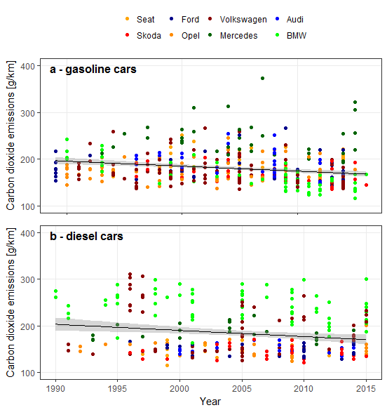
Figure S4: Sensitivity analysis - Time series of on-road CO₂ emissions of selected gasoline (a) and diesel (b) car models sold in Germany; shaded areas represent the 95%-confidence intervals of the fitted regression line; Data source: Irrgang, 2018 based on Spritmonitor (2018a)

Table S2: Sensitivity analysis - Coefficients and summary statistics of the regression models applied to the data sample of 700 variants of 14 models (4 small cars, 6 compact cars, and 4 midsize sedans) from 8 individual manufacturers; data about the front area of vehicles were not collected
Vehicle | Coefficients | Estimate | Standard error | t value | Pr (>abs t) | p value | Adjusted R-squared
 | Equation 1: On-road fuel consumption = α₁+β₁mass
Gasoline | Intercept | 4.37 | 0.51 | 8.64 | <0.001 | <0.001 | 0.13
 | Mass | 2.70e-3 | 4.40e-4 | 6.14 | <0.001
Diesel | Intercept | -2.78 | 0.78 | -3.57 | <0.001 | <0.001 | 0.31
 | Mass | 7.34e-3 | 6.16e-4 | 11.92 | <0.001
 | Equation 1: On-road CO₂ emissions = α₁+β₁mass
Gasoline | Intercept | 101.9 | 11.8 | 8.64 | <0.001 | <0.001 | 0.13
 | Mass | 0.06 | 0.01 | 6.14 | <0.001
Diesel | Intercept | -73.4 | 20.6 | -3.57 | <0.001 | <0.001 | 0.31
 | Mass | 0.19 | 0.02 | 11.92 | <0.001
 | Equation 2: On-road fuel consumption = α₂+β₂power
Gasoline | Intercept | 5.64 | 0.12 | 45.61 | <0.001 | <0.001 | 0.45
 | Power | 0.021 | 0.001 | 15.19 | <0.001
Diesel | Intercept | 3.52 | 0.16 | 22.23 | <0.001 | <0.001 | 0.55
 | Power | 0.034 | 0.002 | 21.02 | <0.001
 | Equation 2: On-road CO₂ emissions = α₂+β₂power
Gasoline | Intercept | 131.4 | 2.88 | 45.61 | <0.001 | <0.001 | 0.45
 | Power | 0.48 | 0.03 | 15.19 | <0.001
Diesel | Intercept | 92.85 | 4.18 | 22.23 | <0.001 | <0.001 | 0.55
 | Power | 0.90 | 0.04 | 21.02 | <0.001
 | Equation 4: On-road fuel consumption = α₄+β₄mass+ β₅power+ β₇year
Gasoline | Intercept | 206.9 | 11.16 | 18.54 | <0.001 | <0.001 | 0.64
 | Mass | -1.25e-3 | 2.70e-4 | -4.63 | <0.001
 | Power | 0.033 | 1.13e-3 | 29.37 | <0.001
 | Year | -0.100 | 5.64e-3 | -17.81 | <0.001
Diesel | Intercept | 237.7 | 19.3 | 12.29 | <0.001 | <0.001 | 0.72
 | Mass | 1.99e-3 | 5.34e-4 | 3.73 | <0.001
 | Power | 0.034 | 1.73e-3 | 19.84 | <0.001
 | Year | -0.118 | 9.71e-3 | -12.17 | <0.001
 | Equation 4: On-road CO₂ emissions = α₄+β₄mass+ β₅power+ β₇year
Gasoline | Intercept | 4590 | 275 | 16.69 | <0.001 | <0.001 | 0.68
 | Mass | -0.020 | 8.64e-3 | -2.36 | 0.019
 | Power | 0.653 | 0.034 | 18.92 | <0.001
 | Year | -2.22 | 0.14 | -15.95 | <0.001
Diesel | Intercept | 6276 | 511 | 12.29 | <0.001 | <0.001 | 0.72
 | Mass | 0.053 | 0.014 | 3.73 | <0.001
 | Power | 0.907 | 0.046 | 19.84 | <0.001
 | Year | -3.119 | 0.256 | -12.17 | <0.001

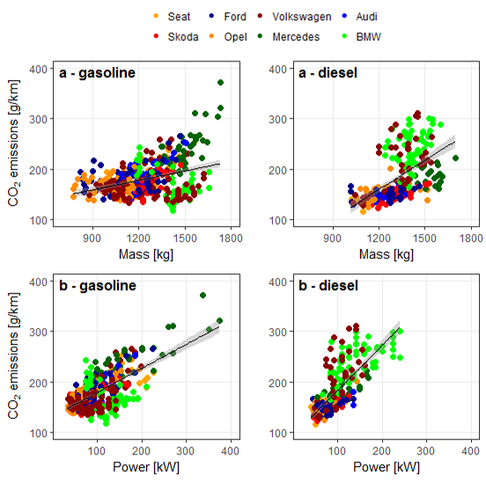
Figure S5: Sensitivity analysis - On-road CO₂ emissions as a function of vehicle mass (a) and power (b); shaded areas represent the 95%-confidence intervals of the fitted regression line

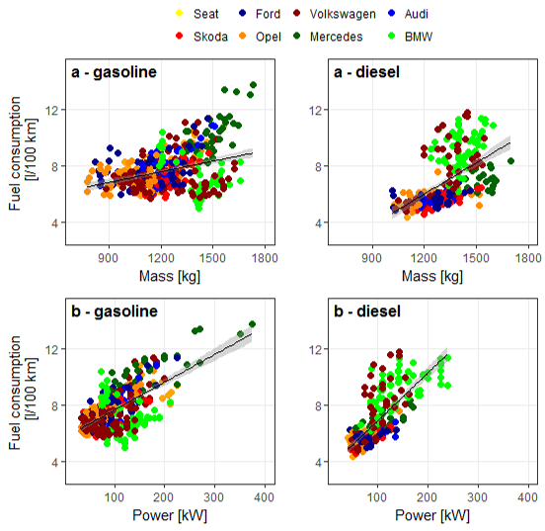
Figure S6: Sensitivity analysis - On-road fuel consumption as a function of vehicle mass (a) and power (b); shaded areas represent the 95%-confidence intervals of the fitted regression line

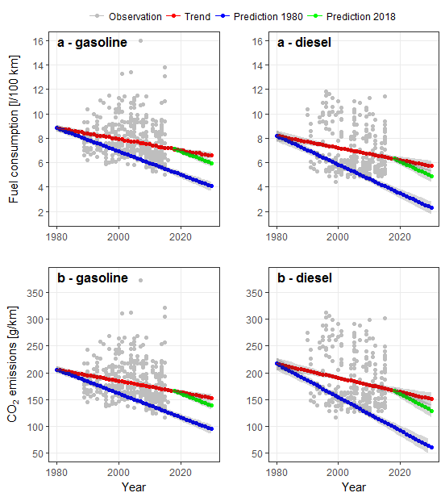
Figure S7: Sensitivity analysis - Fuel consumption (a) and CO₂ emissions (b) as observed and projected for gasoline and diesel model variants of passenger cars, assuming current trends persist (red dots), mass and power was kept at 1980-levels (blue dots), and mass and power will be kept at 2018-levels (green dots)

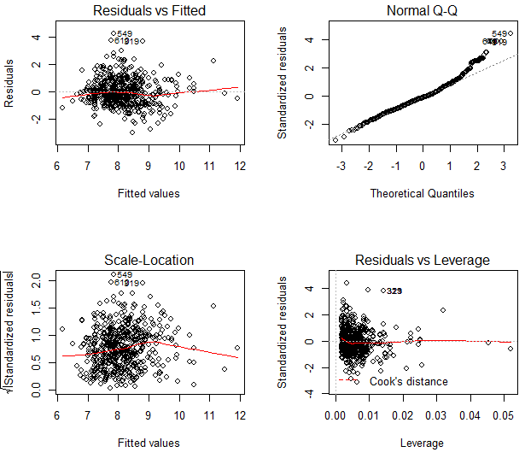
Figure S8: Diagnostic residuals plots - multiple linear regression analysis to predict fuel consumption of gasoline cars as a function of vehicle mass, power, front area, and year of market introduction; residuals plots for CO₂ emissions follow analogously and are not depicted here

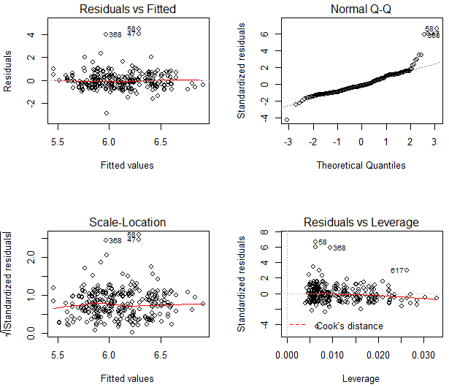
Figure S9: Diagnostic residuals plots - multiple linear regression analysis to predict fuel consumption of diesel cars as a function of vehicle mass, power, front area, and year of market introduction; residuals plots for CO₂ emissions follow analogously and are not depicted here

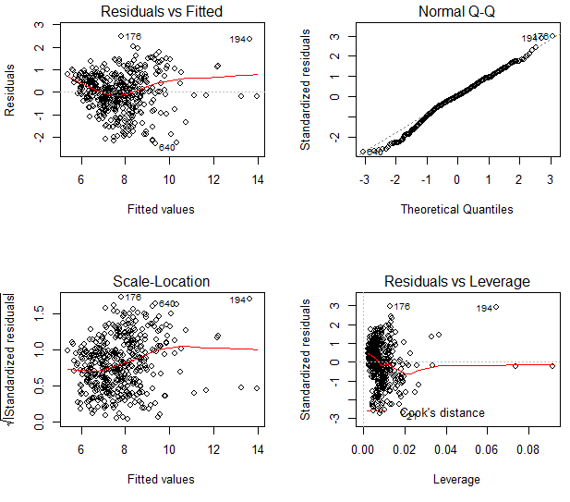
Figure S10: Diagnostic residuals plots – sensitivity analysis for predicting the fuel consumption of gasoline cars by vehicle mass, power, and year of market introduction; residuals plots for CO₂ emissions follow analogously and are not depicted here

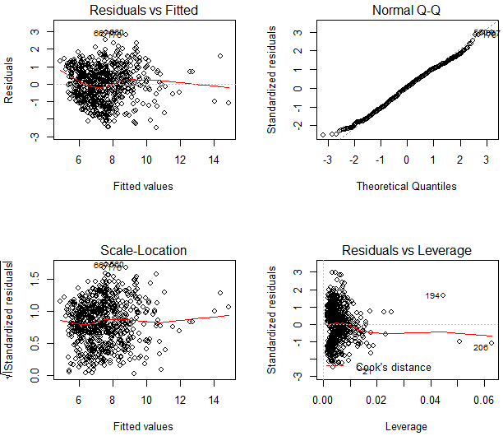
Figure S11: Diagnostic residuals plots - sensitivity analysis for predicting fuel consumption of diesel cars as sampled by vehicle mass, power, and year of market introduction; residuals plots for CO₂ emissions follow analogously and are not depicted here

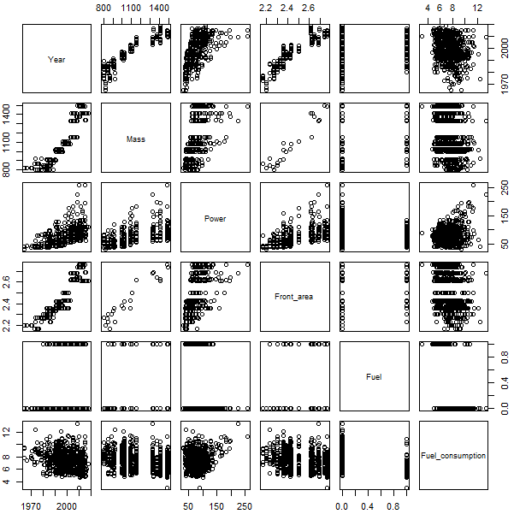
Figure S12: Diagnostic pair plot of attributes of the three compact cars - year of market introduction, mass [kg], power [kW], front area [m²], fuel [diesel, gasoline], and fuel consumption [l/100 km]; each panel represents a scatterplot between the two adjacent variables; the pair plot for CO₂ emissions follows analogously and is not depicted here

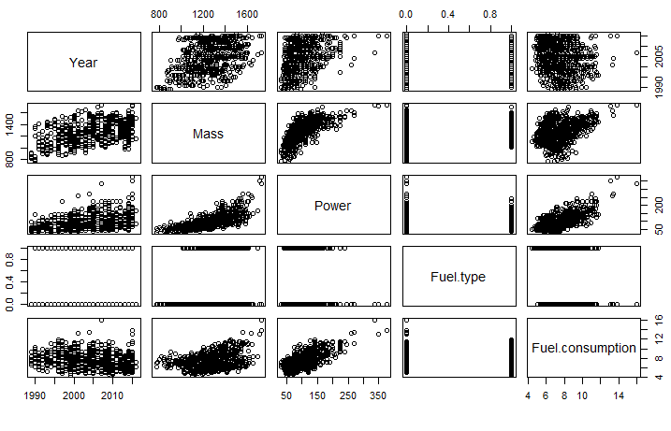
Figure S13: Diagnostic pair plot of vehicle attributes as sampled for the sensitivity analysis - year of market introduction, mass [kg], power [kW], front area [m²], fuel [diesel, gasoline], and fuel consumption [l/100 km]; each panel represents a scatterplot between the two adjacent variables; the pair plot for CO₂ emissions follows analogously and is not depicted here

